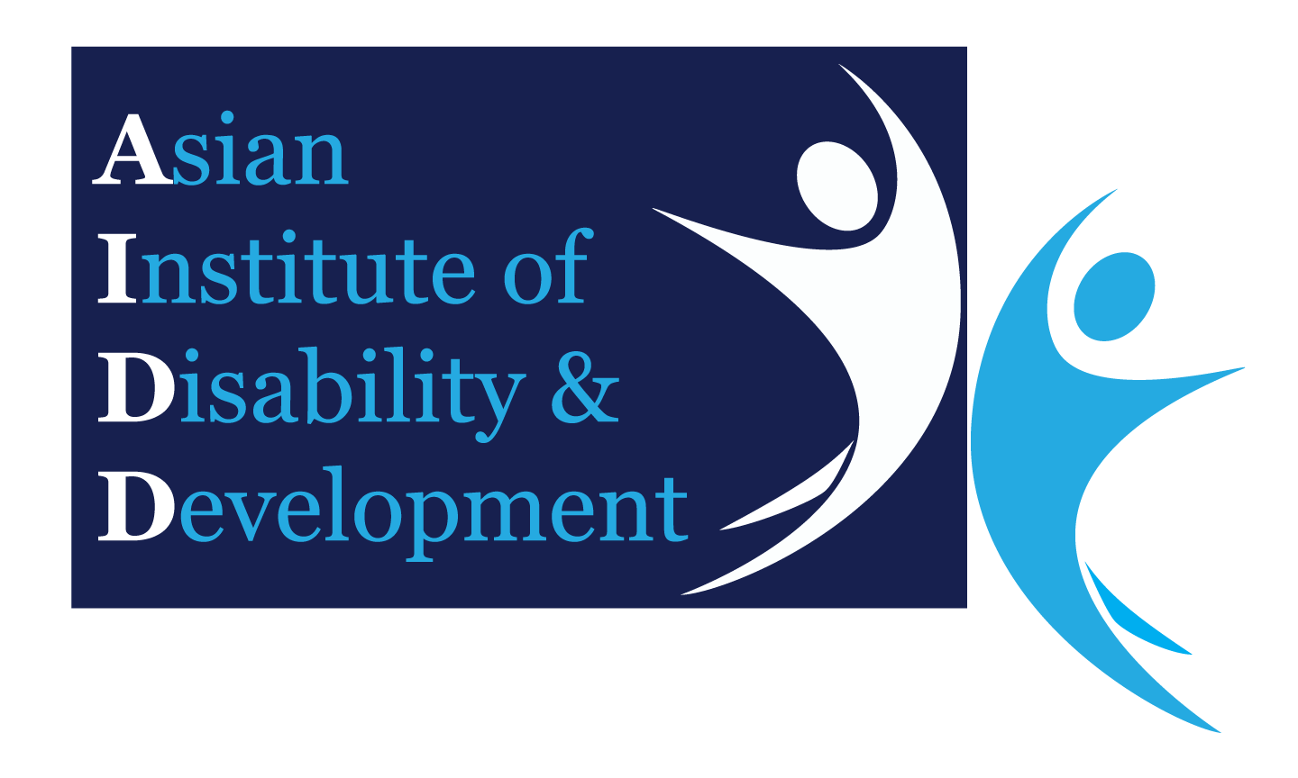
AIDD Ethics Committee
Protocol Variation Request Form

Address for Correspondence: House 76 & 78, Road 14, Block B, Banani R/A, Dhaka - 1213

The committee currently accepts scanned copies of signed forms via email: disabilityasia@gmail.com

ADMINISTRATION
Approval No.
Project Title:
Approval Date: | DD / MM / YYYY
Chief Investigator Name:
Email: |  | Phone:

VARIATION REQUEST HISTORY
First variation request
If previous requests have been made please list what was variations were requested and dates of approval:

THIS VARIATION REQUEST
- Does this variation involve changes to the research personnel working on the project?
Yes No

If yes, please complete below

Addition of research personnel: (leave blank if not applicable)
Name
Qualifications
Mailing address:
Telephone:
Email address
Role on the research project:

Deletion of personnel: (leave blank if not applicable)
Name
Qualifications
Mailing address:
Telephone:
Email address
Role on the research project:

- Does this variation involve changes to the research protocol? Yes No

If yes, where appropriate, present in terms of from the existing protocol to the new protocol and rationale behind the change (Attach the original of any documents that are new or revised as result of the variation. For revised documents, please highlight the changes and identify them with version # and date)

- Does this variation involve recruiting new participants groups, or changing the way in which the participants are to be recruited? Yes No

If yes, provide full details using the following headings:

What is the participant group?

What is the number of participants involved and what is the justification for choosing this number?

From where will the participants be recruited?

How and by whom will participants be approached to receive the invitation to participate?
- Are there any other ethical considerations that are raised by the proposed variations? Yes No

If yes, provide details below:

- Are there any governance considerations that are raised by the proposed variations? Yes No

If yes, provide details below:

- Revised Documentation

Please list all the documentation that needs to be revised and is being submitted with this request for variation.

DECLARATION
In signing this request form, I declare that:
- The research protocol conforms to the BMRC's (Bangladesh Medical Research Council) Guidelines for Ethical Review of Projects involving Human Subjects, which I have read
- The variation will not be implemented prior to receiving approval form the ethics committee.

Name:
Signature |  | Date: | DD / MM / YYYY

