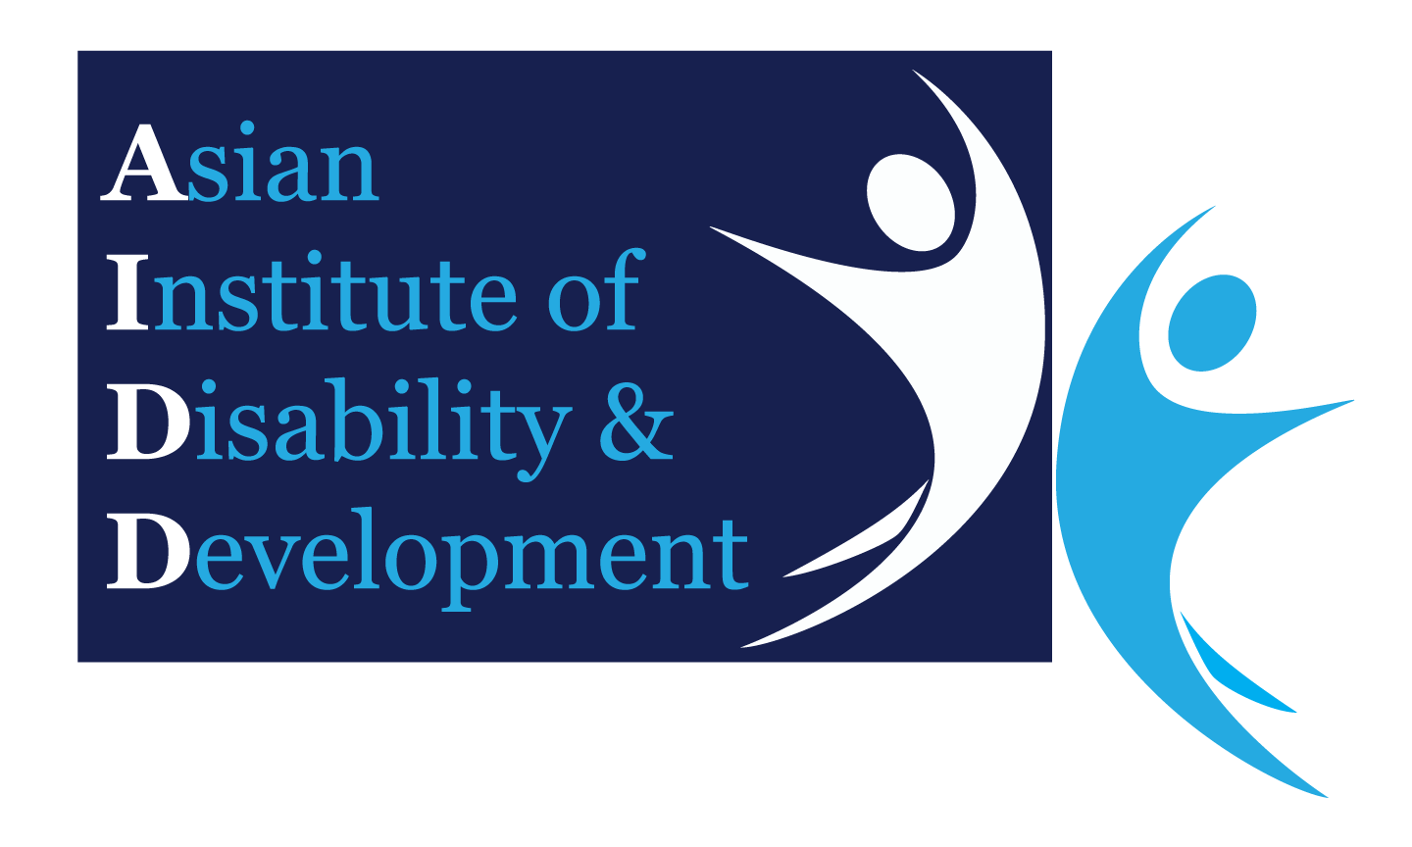
Ethical Approval Application
To Asian Institute of Disability and Development (AIDD) Ethics Committee
(Electronic Format Only)
Date: | DD / MM / YYYY

This application must be typewritten. If the space available is not sufficient, attach details on a separate sheet. If this project includes any information of a commercial or patentable nature, this information should be sent separately and marked “Confidential”. Please submit in electronic format to disabilityasia@gmail.com

You can submit the approved participant information sheets and consent forms. Please also submit the approval letter in electronic format to disabilityasia@gmail.com

Project Title:
Names(s), Titles(s), Qualifications, Dept/Locations and Contact Details
Principal Investigator:
Associates and Co-Investigator:
Proposed Date of project commencement:
Proposed Duration of Project:
Give a succinct but comprehensive aims, hypotheses and potential significance of the project, or of its other purposes, noting also the expected benefits
Give a succinct but comprehensive statement of the scientific background to the project and project plan
Briefly describe all methodology to be used with participants
Give a statement of the possible dangers or ill effects of these procedures and the precautions to be taken to prevent or minimize them
Give a statement on the demands, inconvenience or discomfort to the participants
Give the number, type and age range of all the participants, including controls
Sources and means of recruitment
Will any special relationship exist between the recruiter and the participants?
Criteria for exclusion

Details of any proposed payment to participants
Where will the procedures involving participants be undertaken?
How will risk factors be minimized?
How will information be handled to safeguard confidentiality both during and after completion of the research project?
If the project involves use of medication/drugs/ procedure, give details:
Has this project been submitted to any other Ethics Committee? |  |  |  |  | Yes No
If yes; name of committee
(please attach a copy of approval)
Approval granted? |  |  | Yes No
What do you think are the ethical issues raised by the proposed project considering your previous answers?
Please state your response to them
OBTAINING INFORMED CONSENT
Please note a copy of the explanatory material/information sheet which will be shown to the subjects and the consent form must be included.
Who will explain the project to the potential participants?
Is there a special relationship between the person explaining the project, or any of the investigators, and the participants?
When will the explanation be given?
Will the participants be able to give consent themselves? |  |  |  |  |  | Yes No
If not, why? To whom will the project be explained and who will give consent?
Will written consent be obtained from all participants? |  |  |  |  |  | Yes No
If not, please give reasons?
Who will act as witness?

